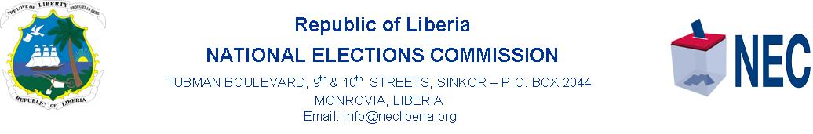
PRESS STATEMENT
NEC Chairperson: Sustained Engagement with Legal Practitioners and Voters Remains Paramount

MONROVIA, 25 OCTOBER 2020……The first in a series of Legal Awareness Forum organized by the Legal Section of the National Elections Commission ended over the weekend in Gbarnga City, Bong County with the acknowledgement by the Commission that providing legal and sustained information to Liberians remains a major priority of the NEC today.

In her acknowledgement, the Chairperson of NEC Davidetta Browne Lansanah said sustained engagement with legal practitioners and voters is paramount and an effective mechanism to building an informed democratic society in Liberia.

The NEC Chairperson spoke in Gbarnga, Bong County at the two-day Legal Awareness Forum for nearly 150 Legal practitioners, including Judges and Attorneys, District Commissioners, Traditional Leaders, Civil Society Groups, namely women and youth groups. Itso brough together members of the Disabled Community from seven counties: Nimba, Lofa, Grand Gedeh, Maryland, Margibi, and host Bong. Four Commissioners of NEC, Chairperson Davidetta Browne Lansanah, Boakai A. Dukuly, Barsee Leo Kpangbai, and Cllr. Ernestine Morgan Awar participated in the Legal Awareness Forum in the City of Gbarnga.

Earlier, the United Nations Development Program (UNDP) Chief Technical Adviser to NEC Lenka Homolkova pointed out that long standing relationship between UNDP and NEC is to help consolidate democracy and to ensure public trust in the Elections Commission of Liberia.

In special remarks on behalf of the Liberian Government, Deputy Justice Minister, Cllr. Nyenati Tuan challenged the participants to serve as ambassadors for NEC spreading the message of peace and helping to safeguard the current peace.

The second of the Legal Awareness Forum to enhance stakeholders’ Understanding of the Legal Electoral Processes for the2020 Special Senatorial Elections and Referendum opens this Friday 30 October 2020 in the city of Buchanan, Grand Bassa County.

In a related development, a two-person Elections Experts delegation from the Independent Elections Commission, INEC of the Federal Republic of Nigeria is expected to arrive in the country this week to help provide technical support for the Voter Roll Update exercise leading to the conduct of the Special Senatorial Election and the Constitutional Referendum.
A NEC Statement quotes a communique from the Special Representative of the President of the Economic Community of West African States, ECOWAS in Liberia, Ambassador Tunde O. Ajisomo to the Chairperson of the National Elections Commission Davidetta Browne Lansanah saying the coming of the two elections experts from Nigeria to the NEC is in furtherance to a formal request made to the ECOWAS Commission for technical assistance to support Liberia by President George Manneh Weah.
According to the communique from the Special Representative of the ECOWAS Commission in Liberia, the two-person ECOWAS Elections Support team is headed by the former Chairperson of the Election Commission of Ghana, Madam Charlotte Ossei and will be deployed for a period of 20 days, beginning 21 October 2020 to 10 November 2020.

Signed by: ____________________.
Prince Dunbar
Communications Officer

